**VISVESVARAYA TECHNOLOGICAL UNIVERSITY**

**“Jnana Sangama”,** Belagavi-590018, Karnataka

**A REPORT**

**on**

**SOCIAL CONNECT AND RESPONSIBILITY**

**(BSCK307)**

**Submitted in partial fulfilment of the requirements for the award of the degree of Bachelor of Engineering**

**In**

**Artificial Intelligence & Machine Learning**

**Submitted by**

**Nihar D**

**1BI24AI403**

**For the academic Year 2024-2025**

**DEPARTMENT OF ARTIFICIAL INTELLIGENCE & MACHINE LEARNING**

**BANGALORE INSTITUTE OF TECHNOLOGY**

K.R. Road, V.V. Pura, Bengaluru-560 004

**VISVESVARAYA TECHNOLOGICAL UNIVERSITY**

**“Jnana Sangama”, Belagavi-590018, Karnataka**

**BANGALORE INSTITUTE OF TECHNOLOGY**

**Department of Artificial Intelligence & Machine Learning**

**K.R. Road, V.V. Pura, Bengaluru-560 004**



***Certificate***

This is to certify that **Social Connect and Responsibility (BSCK307)** work carried out by

Nihar D

**1BI24AI403**

a bonafide student of **Bangalore Institute of Technology** in partial fulfilment for the award of degree of **Bachelor of Engineering**in **Artificial Intelligence & Machine Learning** under Visvesvaraya Technological University, Belagavi, during the academic year 2024-25 is true representation of activities completed satisfactorily.

|  |  |  |
| --- | --- | --- |
| **Dr. Manjunatha P B** | **Dr. D.G Jyothi** | **Dr. Aswath M U** |
| Asst. Professor | Professor & HoD | Principal |
| Dept. of AI&ML | Dept. of AI&ML | BIT |
| BIT, Bengaluru | BIT, Bengaluru. | Bengaluru. |

**VISVESVARAYA TECHNOLOGICAL UNIVERSITY**

**“Jnana Sangama”,** Belagavi-590018, Karnataka

**BANGALORE INSTITUTE OF TECHNOLOGY**

K.R. Road, V.V. Puram, Bengaluru 56004

**DEPARTMENT OF ARTIFICIAL INTELLIGENCE &MACHINE LEARNING**

**SCR ACTIVITY POINTS SUMMARY SHEET**

|  |  |  |  |  |  |
| --- | --- | --- | --- | --- | --- |
| **STUDENT INFORMATION** | | | | | |
| **NAME** | Nihar D | | | | |
| **USN** | 1BI24AI403 | | | | |
| **BRANCH** | Artificial Intelligence and Machine Learning | | | | |
| **SEM** | III Sem | | | | |
| **ENTRY TO PROGRAM** | Regular/Lateral/Change of College (Tick the Appropriate) | | | | |
| **ACTIVITY DETAILS** | | | | | |
| **Activity** | ACT-1 | ACT-2 | ACT-3 | ACT-4 | ACT-5 |
| **Marks Allotted** | 20 | 20 | 20 | 20 | 20 |
| **Marks Scored** |  |  |  |  |  |

|  |  |
| --- | --- |
| **Evaluated By:** | |
| **Dr. Manjunatha P B**  **Assistant Professor**  Dept. of Artificial Intelligence & Machine Learning  Bangalore Institute of Technology,  K. R. Road, V. V. Puram, Bengaluru - 04 |  |

**Acknowledgement**

I would like to express my sincere gratitude to the Principal of the college, **Dr. Aswath M.** **U.,** for providing the necessary resources and support to carry out SCR Activities.

I deeply thankful to the Head of the Department, AI&ML Department, **Dr. Jyothi D. G.,** for her guidance and encouragement throughout the duration of SCR Activities.

I immensely grateful to our Guide and SCR Coordinator, **Dr. Manjunatha P B,** Assistant Professor, Department of AI&ML for his invaluable support, expertise, and constructive feedback that helped shape SCR Activities.

I would also like to extend my heartfelt thanks to our peers, for their collaborative efforts and constant support during SCR Activities. Their insights and assistance were invaluable throughout the development process.

Thank you all for your unwavering support and encouragement.

Nihar D

1BI24AI403

**Contents**

|  |  |  |
| --- | --- | --- |
| **Sl. No.** | **Description** | **Page No.** |
| 1 | Introduction |  |
| 2 | Pro-Bono Activity |  |
| 3 | Activity 1: Plantation and adoption of a tree |  |
| 4 | Activity 2: Heritage walks and crafts corner |  |
| 5 | Activity 3: Organic farming and Waste management |  |
| 6 | Activity 4: Water Conservation |  |
| 7 | Activity 5: Food Walk |  |
| 8 | Conclusion |  |

# Introduction

# Pro-Bono Activity

## Individual

### Objectives

### Description of Social responsibilities undertaken

### Impact

## National Level Organization

### Objectives

### Description of Social Responsibilities Undertaken

### Impact

## International Level organization:

### Objectives

### Description of Social Responsibilities Undertaken

### Impact

## Your commitment for SCR

### Description of Social Responsibilities Undertaken

### Description of Social Responsibilities Undertaken

ACTIVITY – 1

PLANTATION AND ADOPTION OF A TREE:

# 1. Environmental Benefits

Improves Air Quality: Trees absorb pollutants and produce oxygen, contributing to a healthier campus environment.

Mitigates Climate Change: By sequestering carbon dioxide, trees help reduce the overall carbon footprint of the institution.

Enhances Biodiversity: Trees provide habitats for various species of birds and insects, enriching campus biodiversity.

# 2. Educational Value

Practical Learning: Engineering students, especially those in fields like civil, environmental, or agricultural engineering, can apply concepts such as sustainable design, hydrology, and soil conservation.

Awareness and Responsibility: Engaging in tree plantation teaches students about ecological balance, encouraging them to take active roles in protecting the environment.

Innovative Opportunities: The initiative can inspire projects related to renewable energy (e.g., solar panels integrated with tree canopies) or smart irrigation systems.

**3. Community and Aesthetic Impact**

Campus Beautification: Trees enhance the visual appeal of the college, creating shaded areas for relaxation and study.

Community Building: The activity fosters teamwork among students, faculty, and staff, promoting a sense of belonging and cooperation.

Long-term Legacy: Adopted trees symbolize the bond between students and the institution, leaving behind a lasting contribution for future generations.

1. **Practical and Cultural Relevance in India**

Sustainable Development Goals (SDGs): The activity aligns with India's commitment to SDG 13 (Climate Action) and SDG 15 (Life on Land).

Cultural Connection: Trees hold significant cultural and spiritual value in Indian traditions, emphasizing harmony with nature.

1. **Personal Development**

Instills Discipline: Taking responsibility for a tree cultivates discipline and a sense of achievement.

Fosters Emotional Connection: Watching a tree grow builds empathy and appreciation for nature’s processes.

Tree plantation and adoption in an engineering college is not just an act of environmental conservation but also an investment in the holistic development of students and the campus ecosystem.

ACTIVITY – 2

Heritage walks and crafts corner

## Heritage Walks and Crafts Corner: Unearthing Culture

## and Craftsmanship

# Veerabhadra Temple, Lepakshi

Veerabhadra temple is a [Hindu temple](https://en.wikipedia.org/wiki/Hindu_temple" \o "Hindu temple) located in the [Lepakshi](https://en.wikipedia.org/wiki/Lepakshi" \o "Lepakshi), in the state of [Andhra Pradesh](https://en.wikipedia.org/wiki/Andhra_Pradesh" \o "Andhra Pradesh), [India](https://en.wikipedia.org/wiki/India" \o "India). The temple is dedicated to the [Virabhadra](https://en.wikipedia.org/wiki/Virabhadra" \o "Virabhadra), a fierce form of the god Shiva.

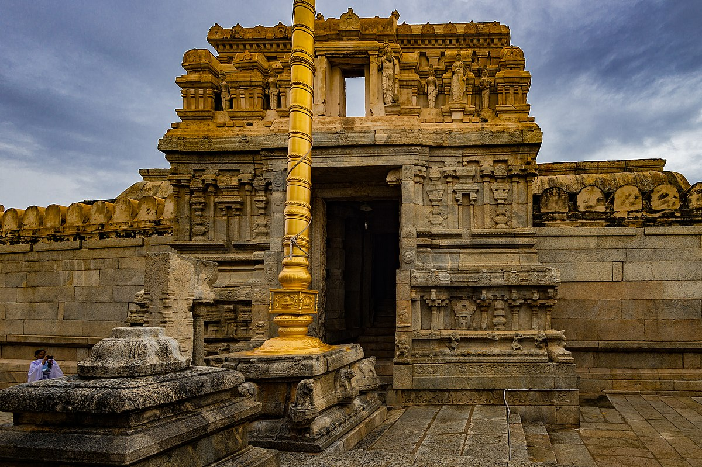Built in the 16th century, the architectural features of the temple are in the [Vijayanagar style](https://en.wikipedia.org/wiki/Vijayanagara_architecture" \o "Vijayanagara architecture) with profusion of carvings and paintings at almost every exposed surface of the temple. It is one of the centrally protected [monuments of national importance](https://en.wikipedia.org/wiki/Monuments_of_National_Importance" \o "Monuments of National Importance) and is considered one of the most spectacular Vijayanagar temples. The fresco paintings are particularly detailed in very bright dresses and colours with scenes of [Rama](https://en.wikipedia.org/wiki/Rama" \o "Rama) and [Krishna](https://en.wikipedia.org/wiki/Krishna" \o "Krishna) from the epic stories of the [Ramayana](https://en.wikipedia.org/wiki/Ramayana" \o "Ramayana), the [Mahabharata](https://en.wikipedia.org/wiki/Mahabharata" \o "Mahabharata) and the [Puranas](https://en.wikipedia.org/wiki/Puranas" \o "Puranas) and they are well preserved.

There is a very large [Nandi](https://en.wikipedia.org/wiki/Nandi_(bull)" \o "Nandi (bull)) (bull), mount of [Shiva](https://en.wikipedia.org/wiki/Shiva" \o "Shiva), about 200 metres (660 ft) away from the temple which is carved from a single block of stone, which is said to be one of the largest of its type in the world. The temple is home to many Kannada inscriptions as its located close to Karnataka border.

**Hanging Column**

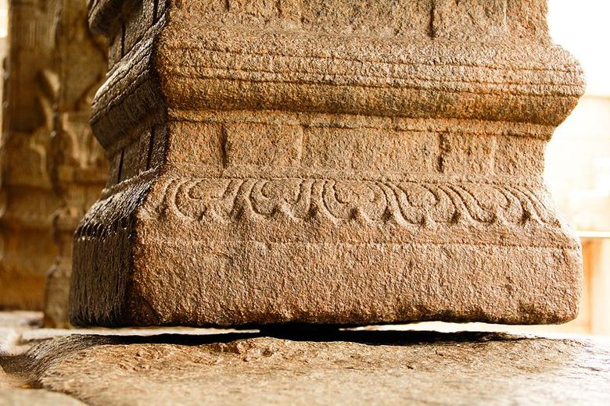Looking down once more, I was stunned to see the ‘Hanging column’; a column that does not touch the floor. Apparently, the British were equally stunned & tried to find out how the column stood. In doing so, they moved it slightly. That led to many other columns & beams around re-aligning themselves. Scared that the temple would collapse, they let it be & there were no further investigations.

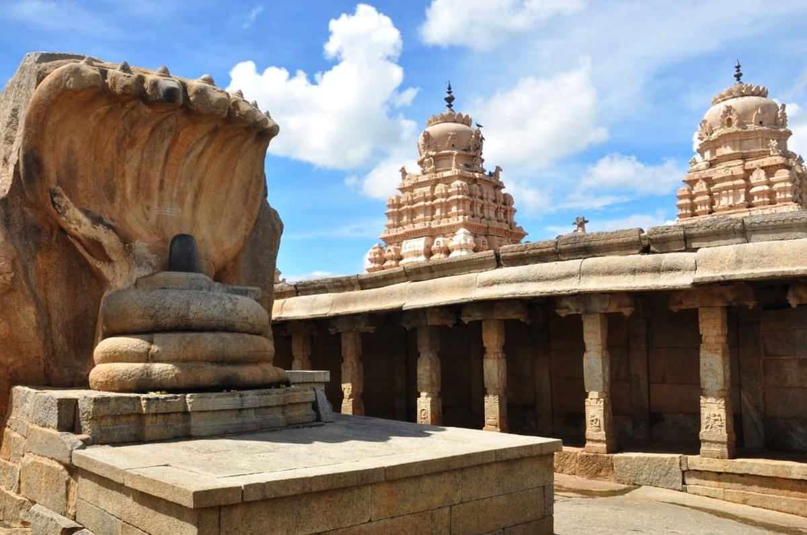I had more such stories in store for me. As we approached the Nagalinga where a Shivalinga sits shielded by a coiled, 7-headed snake. During lunch break, a group of brothers waited outside the kitchen at this spot, as their mother hurried to cook their meal. Not wanting to waste their time waiting, they built this in the 30 minutes that it took their mother to prepare the food. When she came out to call them, she was surprised to see this and the power of surprise from her vision (also called nazar) was so strong that the sculpture cracked in two places.

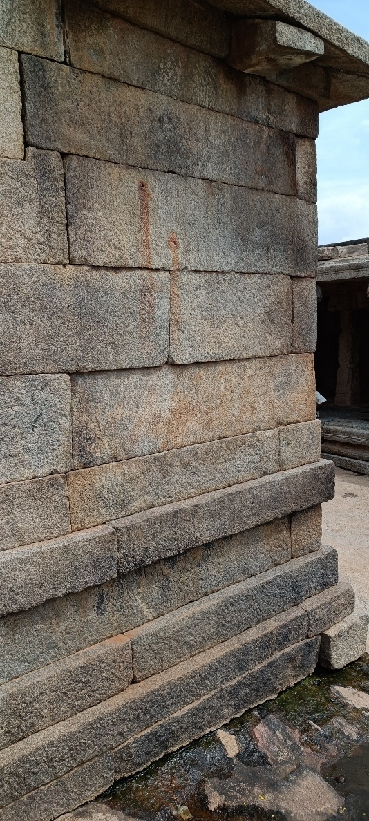Then we pointed out to two reddish smear marks on a stone wall nearby. We got to know that this is the blood from Virupanna’s eyes, when he threw them here. “And why would he do such a thing”? Well, apparently, when the king received the embezzlement complaint, he ordered that Virupanna’s eyes be gouged out & he be blinded; as was the customary punishment those days. When the loyal Virupanna heard this, he decided to carry out the task himself. And, the Kalyana mantapa remained unfinished.

It was the last part to be built in the temple complex.

**Jatayu Theme Park, Lepakshi: Rising of the fallen bird**

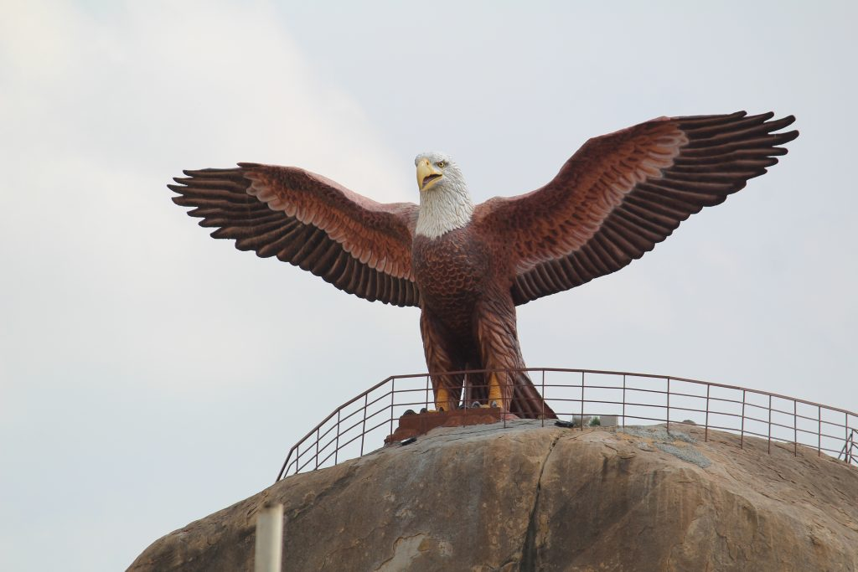

Jatayu Theme Park has a large statue of a bird perched on the hilltop. The bird is the mythical 'Jatayu'. The town has been named as a tribute to Jatayu. Mythology states that Lepakshi is the place where Jatayu fell, wounded by Ravana while abducting Sita. Rama is said to have commanded the bird to rise 'Le Pakshi', and hence the name Lepakshi.

**Nandi, Lepakshi**

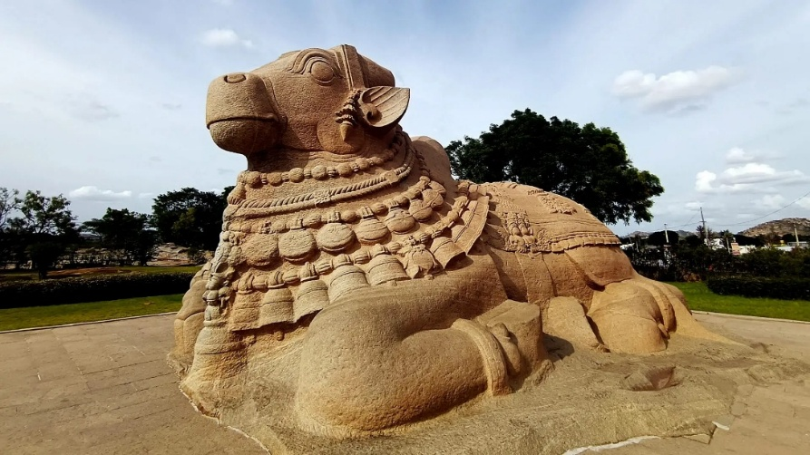

At last, we stopped at the Nandi on way out of Lepakshi. It is India’s largest Nandi, carved out of monolithic granite.

**Isha Foundation, Chikkaballapura**

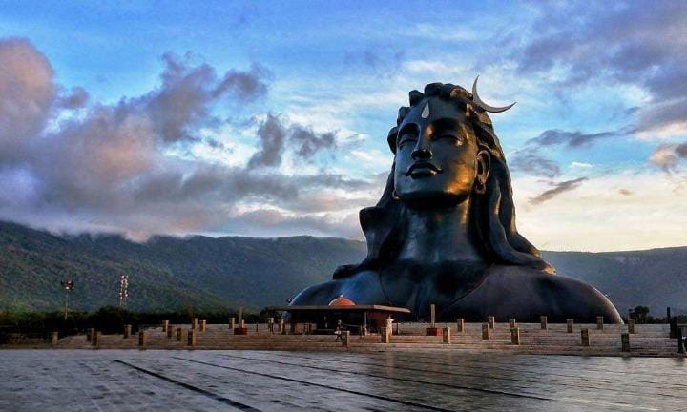

The Isha Shiva Statue in Chikkaballapura, Karnataka, stands 112 feet tall and represents Lord Shiva as the Adiyogi, the first yogi. Located near Nandi Hills, it was inaugurated in 2017 by the Isha Foundation. The statue symbolizes spiritual awakening and promotes the practice of yoga. It has become a major attraction for both spiritual seekers and tourists.

**GEO Tagged Photos of the activity**

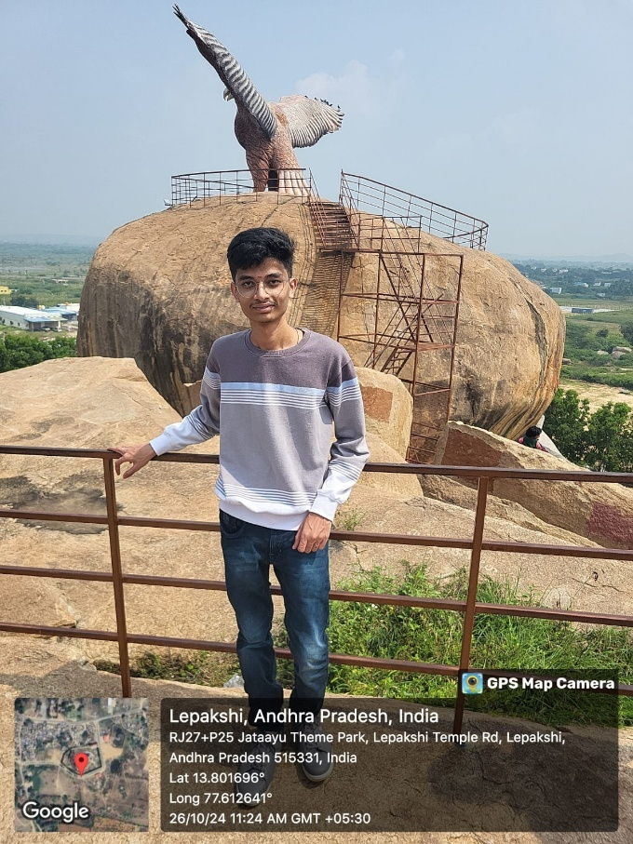

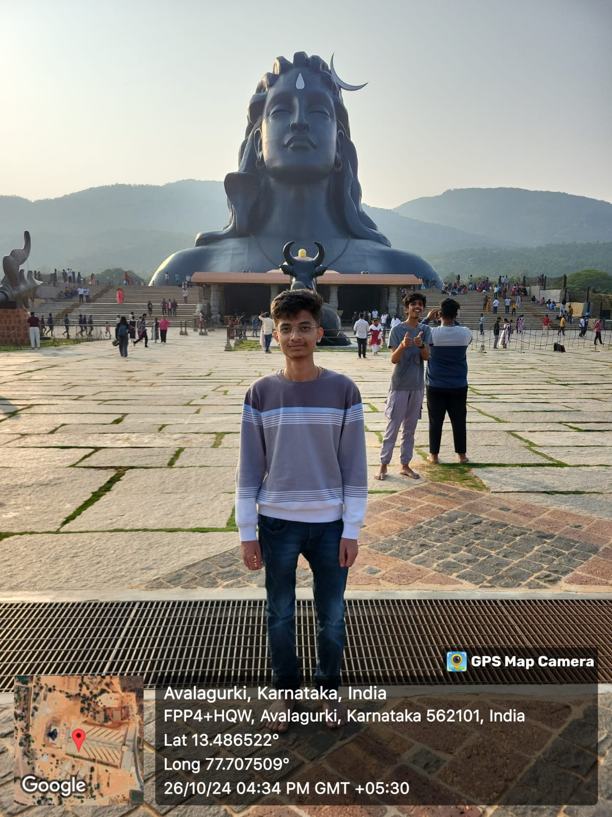

# ACTIVITY – 3

Organic farming and Waste management

**1. State and Local Regulations Regarding Organic Farming and Waste Management in Karnataka**

* Organic Farming Regulations:

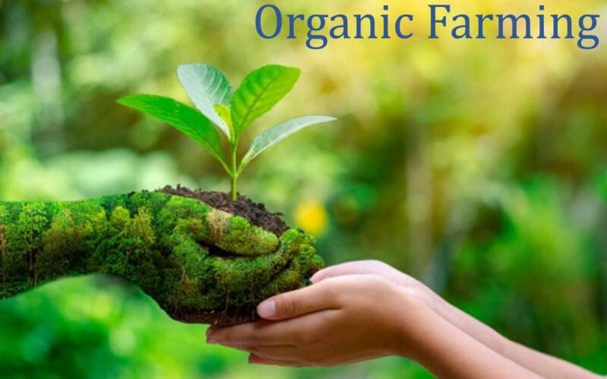

* + Karnataka follows the National Programme for Organic Production (NPOP) and the National Organic Farming Research Institute standards for certifying organic farms.
* Waste Management Regulations:

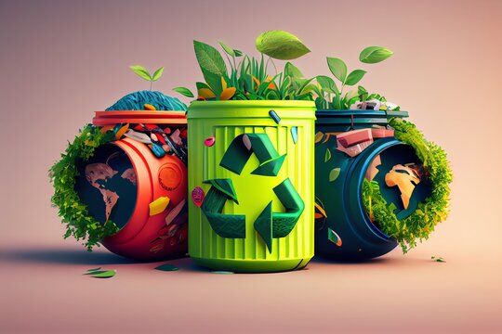

* + Karnataka has adopted the Solid Waste Management Rules (2016), which mandate the segregation of organic (wet) and inorganic (dry) waste at the source, as well as separate collection and disposal processes. These rules apply across urban and rural areas in the state.
* Organic Waste Management: Karnataka's regulations also encourage Waste-to-Compost schemes, particularly in urban and peri-urban areas.

**2. Process of Organic Farming and Waste Management**

* Soil Health Management: This includes using organic compost, cow dung, green manure, and biological pest control.

**3. Category and Source of Organic Waste**

Organic waste can be broadly categorized into the following types:

* Agricultural Waste: This includes crop residues such as straw, leaves, and stalks, as well as animal manure.
* Food Waste: Organic waste generated from households, markets, and food processing units.

**4. Composting Process and Compost Material**

* Composting Process:
  1. Collection: Organic materials such as crop residues, green waste, food scraps, and manure are collected.
  2. Preparation: The materials are chopped or shredded to ensure faster decomposition.
  3. Pile Formation: The materials are stacked in compost bins or piles, with alternating layers of “greens” and “browns”
  4. Aeration and Turning: The pile is turned regularly to allow oxygen to reach the decomposing materials, speeding up the process.
  5. Maturation: After several weeks to months, the compost is mature and ready to be used.
* Compost Material: Common materials used for composting in Karnataka include crop residues (paddy straw, sugarcane leaves), livestock manure (cow dung, poultry manure), food waste (vegetable scraps, kitchen waste), and green waste (grass clippings, tree leaves).

**5. Site Selection for Compost Piles**

The ideal location for compost piles or bins is critical to the success of composting:

* Accessibility: The site should be easily accessible to transport organic waste.
* Ventilation: It should be an open, well-ventilated area to promote aerobic decomposition.

**Role of Individual**

**1. Adopting Organic Farming Practices**

* Transition to Organic Farming: Farmers can shift from conventional farming to organic methods by avoiding synthetic pesticides, fertilizers, and GMOs. They can adopt crop rotation, agroforestry, and the use of compost and organic manure to maintain soil fertility.

**2. Segregating and Managing Waste at the Household Level**

* Waste Segregation: Households can segregate wet (organic) waste from dry waste, which helps streamline the collection and composting process.

**3. Promoting Sustainable Consumption and Environmental Awareness**

* Choosing Organic Products: By purchasing organic products, individuals support farmers who practice organic farming, thus promoting sustainability and reducing the environmental footprint of conventional agriculture.

**4. Contributing to the Health of Local Ecosystems**

* Minimizing Chemical Use: By avoiding synthetic pesticides and fertilizers in household gardens or small-scale farming, individuals can help prevent harmful chemicals from leaching into local water bodies, thus protecting water resources.

**5. Supporting and Engaging with Regulatory and Policy Measures**

* Engaging in Policy Advocacy: Individuals can engage with local government bodies and the Karnataka State Pollution Control Board (KSPCB) to advocate for better waste management and organic farming policies.

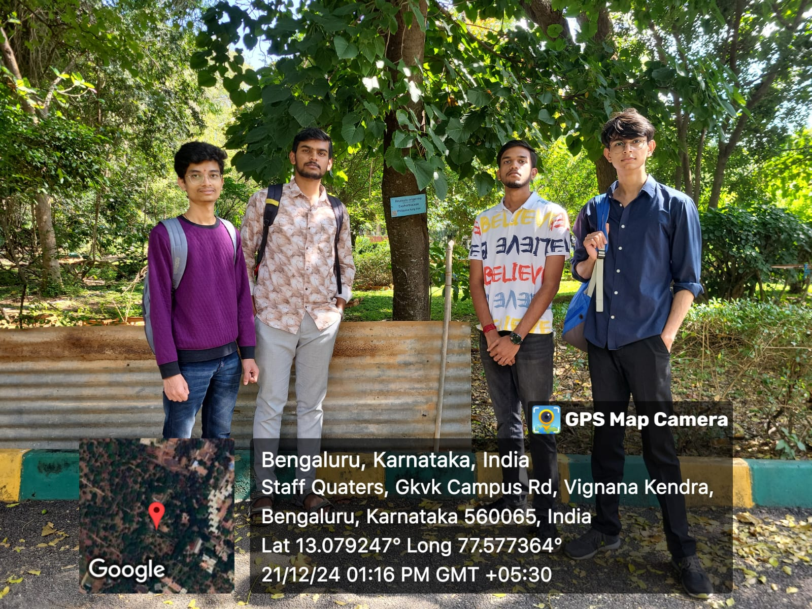**GEO Tagged Photos of activity**

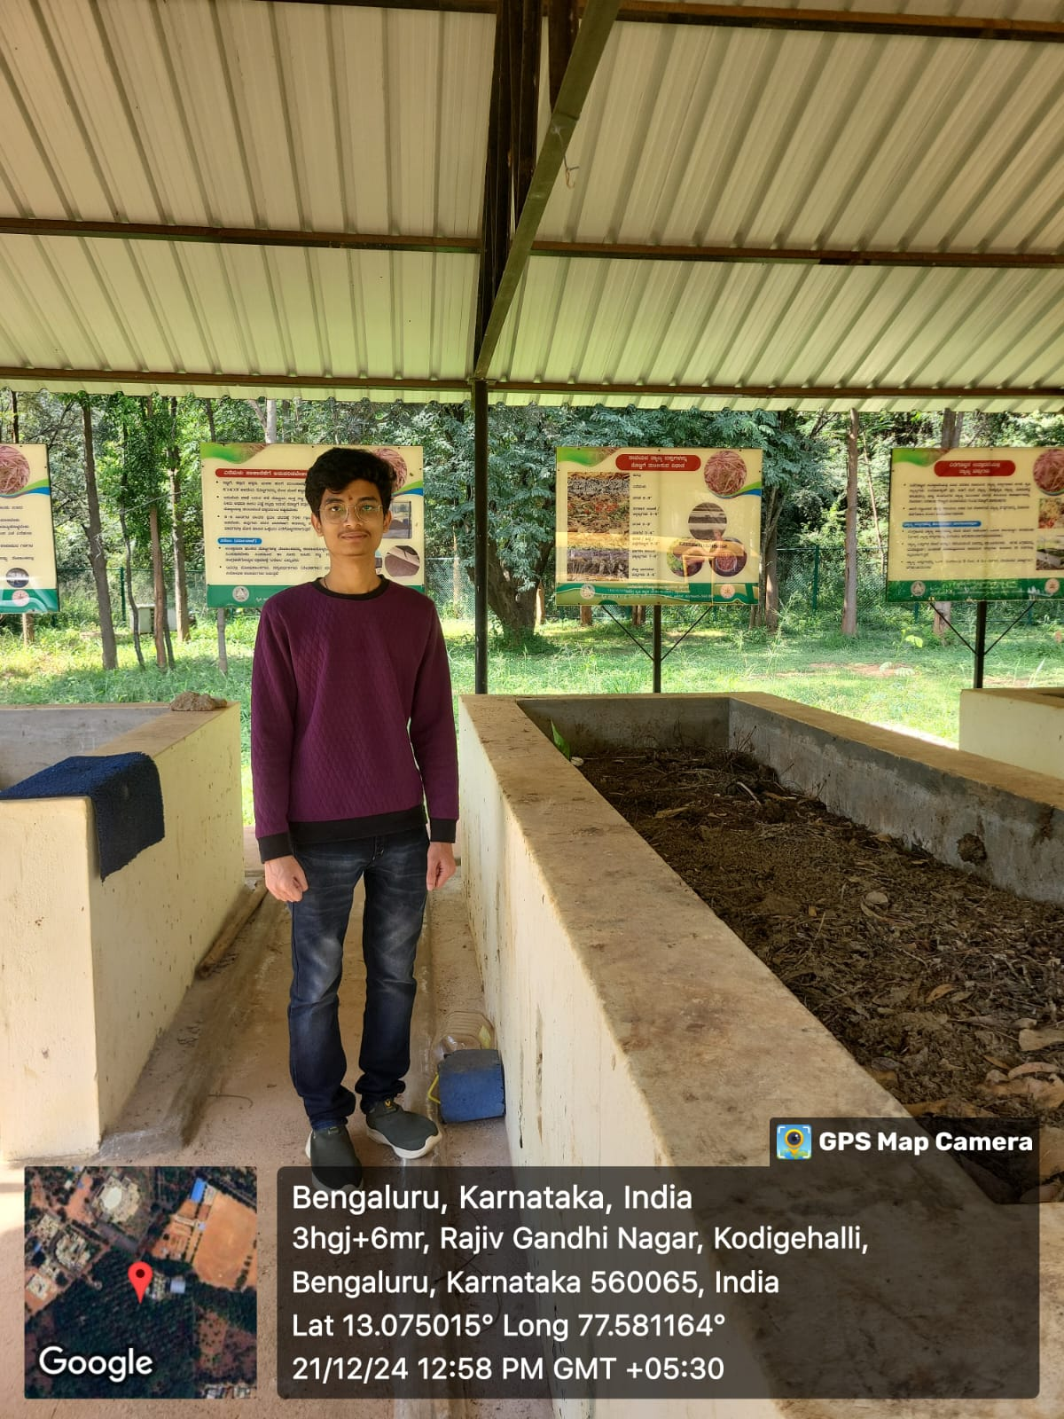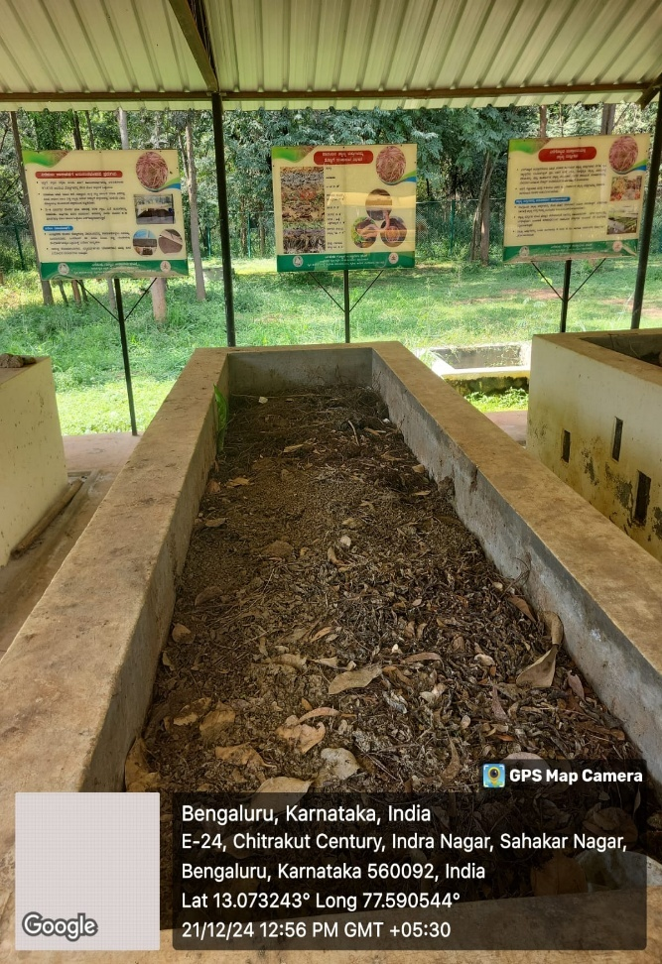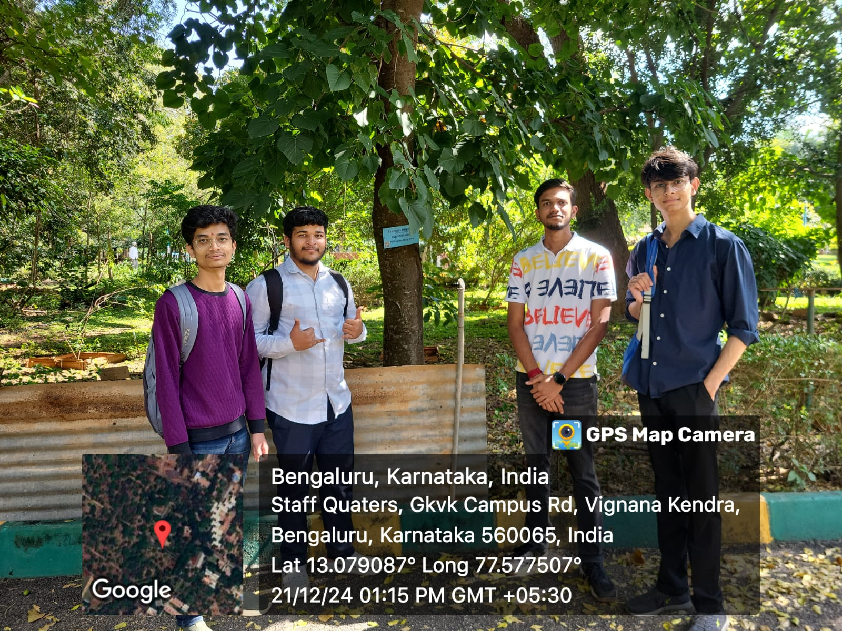

**ACTIVITY – 4**

Water Conservation

**Water conservation** aims to [sustainably](https://en.wikipedia.org/wiki/Sustainably" \o "Sustainably) manage the [natural resource](https://en.wikipedia.org/wiki/Natural_resource" \o "Natural resource) of [fresh water](https://en.wikipedia.org/wiki/Fresh_water" \o "Fresh water), protect the [hydrosphere](https://en.wikipedia.org/wiki/Hydrosphere" \o "Hydrosphere), and meet current and future human [demand](https://en.wikipedia.org/wiki/Demand" \o "Demand).



Water conservation makes it possible to avoid [water scarcity](https://en.wikipedia.org/wiki/Water_scarcity" \o "Water scarcity). It covers all the policies, strategies and activities to reach these aims. Population, household size and growth and affluence all affect how much water is used.

[Climate change](https://en.wikipedia.org/wiki/Climate_change" \o "Climate change) and other factors have increased pressure on natural [water resources](https://en.wikipedia.org/wiki/Water_resources" \o "Water resources).

**Need for water conservation**

Water conservation is important for many reasons, including:

* Limited Freshwater Resources
* Increasing Water Scarcity
* Depletion of Groundwater
* Ecosystem Preservation
* Agricultural Sustainability

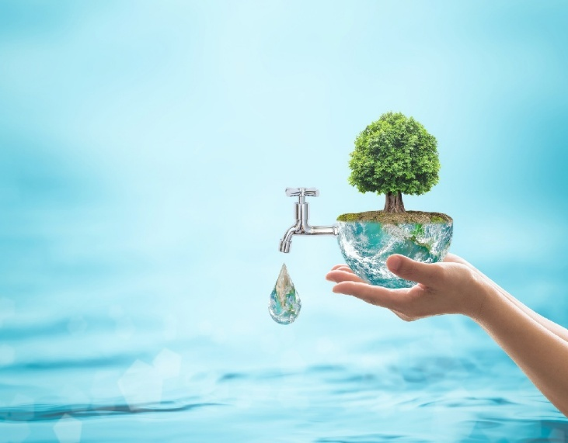

**Importance of water conservation**

* Protecting water bodies

Conserving water helps protect aquatic environments and drinking water resources.

* Preventing water pollution

Soil and water conservation practices can prevent pollutants from entering water bodies.

* Saving money

Conserving water can lower utility bills and reduce the need for costly water supply and wastewater treatment facilities.

* Improving food production

Water scarcity can lead to food shortages, as much of the world's freshwater is used for crop irrigation.

* Ensuring enough usable water

Conserving water is the only way to ensure enough water for future generations.

**Report on Water Conservation Practices in Surrounding Villages and Implementation at BIT Campus**

**1. Present Practices in the Surrounding Villages and Their Implementation on the BIT Campus**. **Water Conservation in Surrounding Villages**

In many villages surrounding BIT, water conservation is a pressing need due to the unpredictable monsoon patterns and over-exploitation of groundwater resources.

**a. Rainwater Harvesting**:  
Rainwater harvesting is a widespread practice in rural Karnataka, where rooftops, open spaces, and agricultural fields are used to collect and store rainwater.

**b. Check Dams**:  
Check dams are small, low-cost structures built across seasonal rivers or streams to capture rainwater during the monsoon.

**c. Krishi Hondas (Agricultural Ponds)**:  
Krishi Hondas are traditional water storage ponds constructed by farmers to collect and store rainwater for irrigation during dry spells.

**2. Rainwater Harvesting**

**Rainwater Harvesting** involves the collection and storage of rainwater from rooftops, paved areas, or other surfaces, preventing runoff and reducing the pressure on groundwater systems.

It is a sustainable way to manage water resources, especially in areas where water supply is irregular.

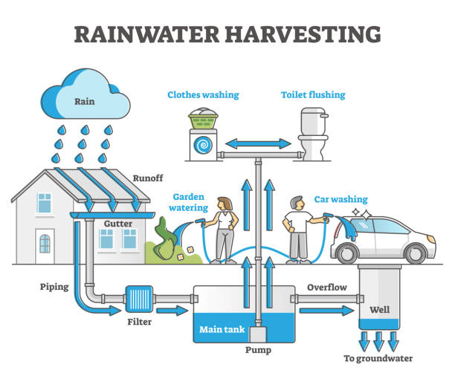

**3. Check Dams**

A **Check Dam** is a small dam built across seasonal rivers or streams to hold water during the monsoon and allow it to gradually percolate into the ground, recharging groundwater levels.

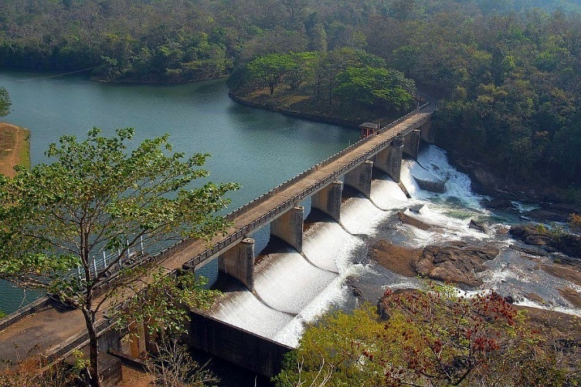

**4. Krishi Hondas (Agricultural Ponds)**

**Krishi Hondas** are small ponds traditionally built by farmers in rural Karnataka to store rainwater for agricultural use. These ponds help farmers store water during the rainy season and use it during periods of drought or in dry spells for irrigation.

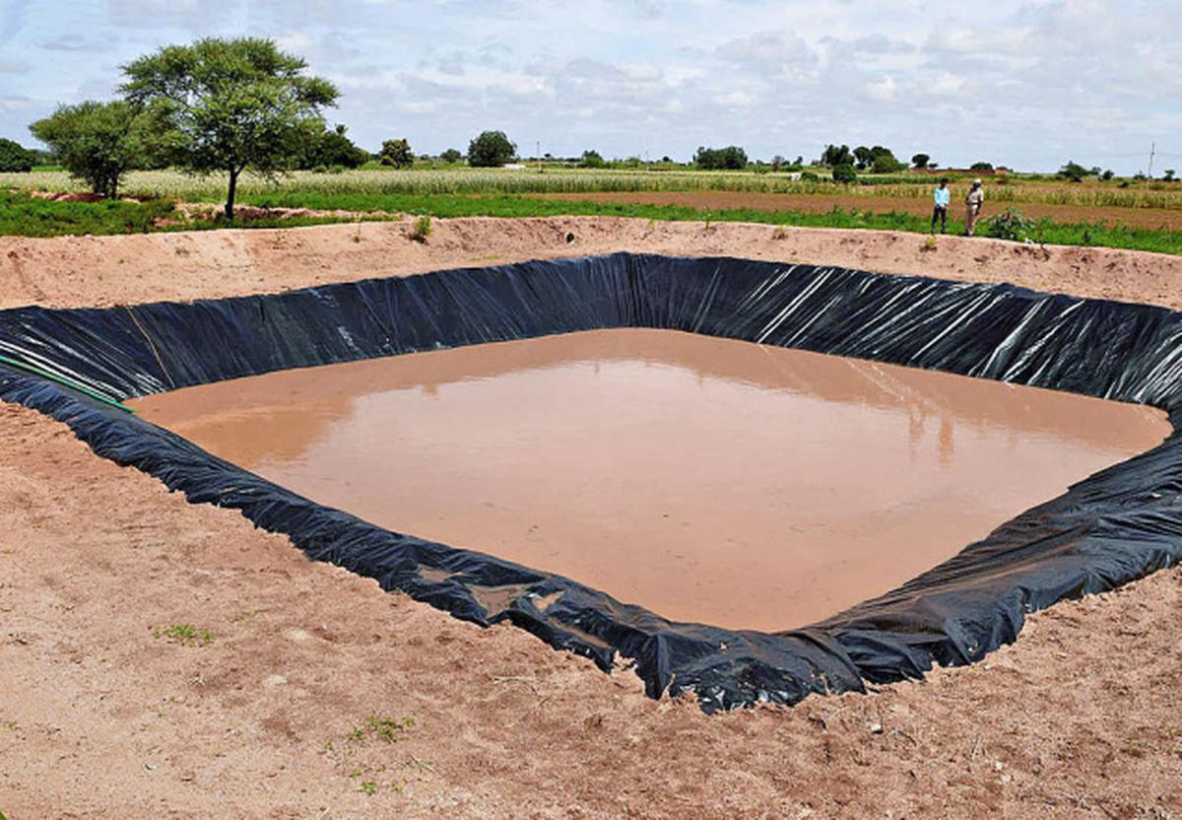

**5. Conclusion and Future Recommendations**

Water conservation is a critical issue for both rural and urban communities in Karnataka. Implementing practices like rainwater harvesting, check dams, and Krishi Hondas can significantly help in managing water resources efficiently, especially in regions experiencing water scarcity.

**Future Recommendations for BIT:**

* **Implement Campus-wide Rainwater Harvesting**: Ensure that all campus buildings are equipped with rainwater harvesting systems.
* **Collaboration with Local Villages**: Work with surrounding villages to construct check dams and Krishi Hondas for mutual benefit.
* **Awareness Campaigns**: Conduct workshops and awareness campaigns to educate students and staff about water conservation techniques and their importance.
* **Research Initiatives**: Encourage students and faculty to research innovative methods of water conservation that can be applied to both rural and urban settings.

By focusing on these areas, BIT can significantly reduce its water consumption, contribute to the local community’s water security, and create a sustainable campus for future generations.

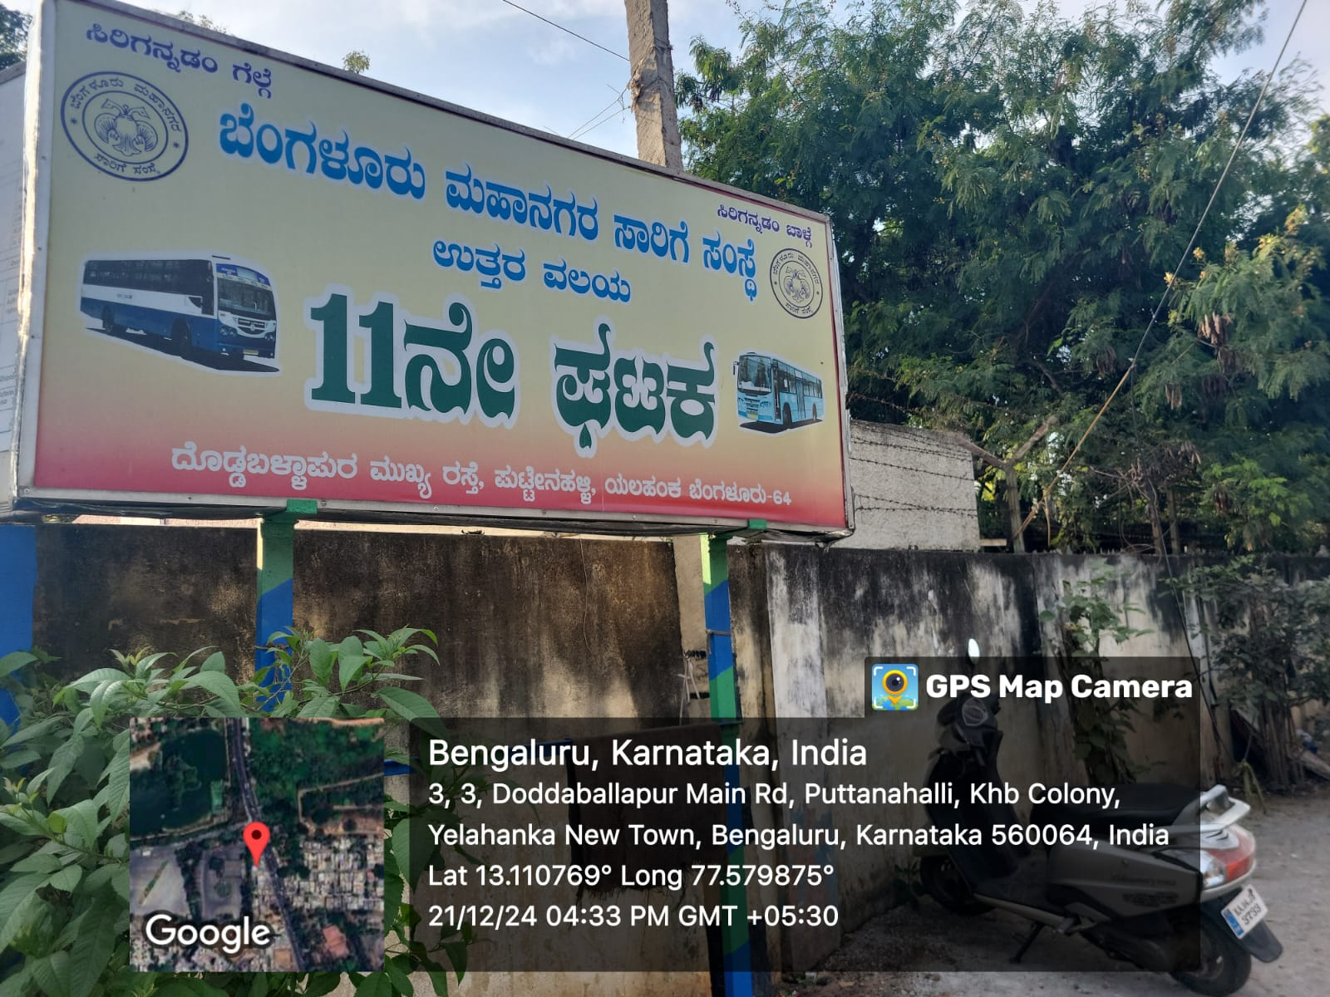  **GEO Tagged photos of Activity**

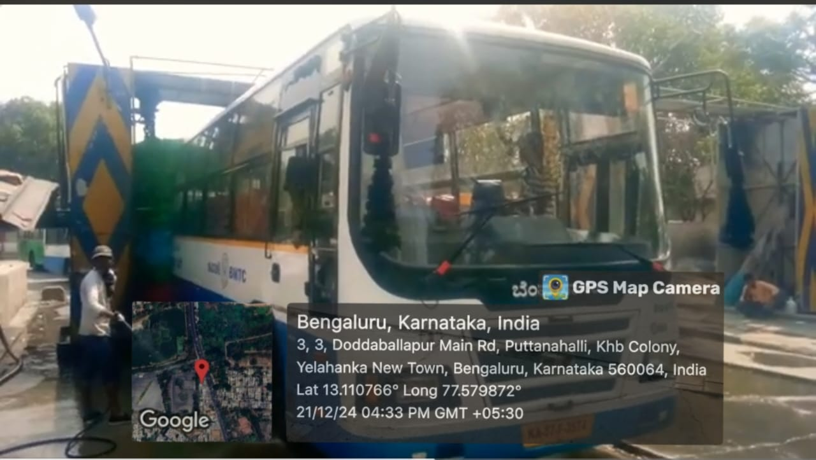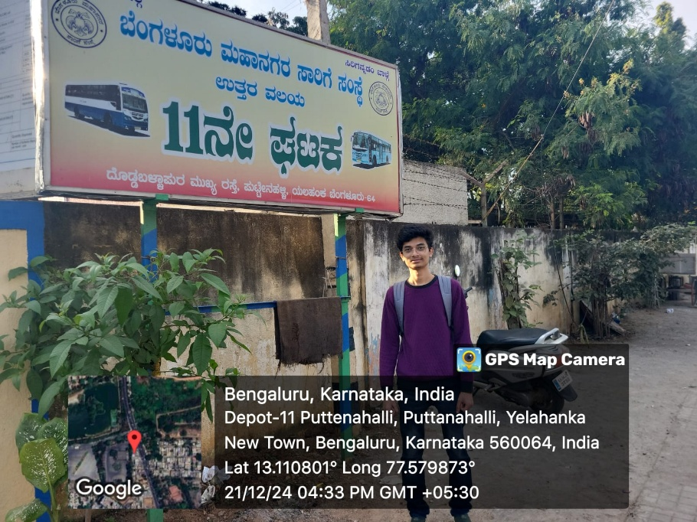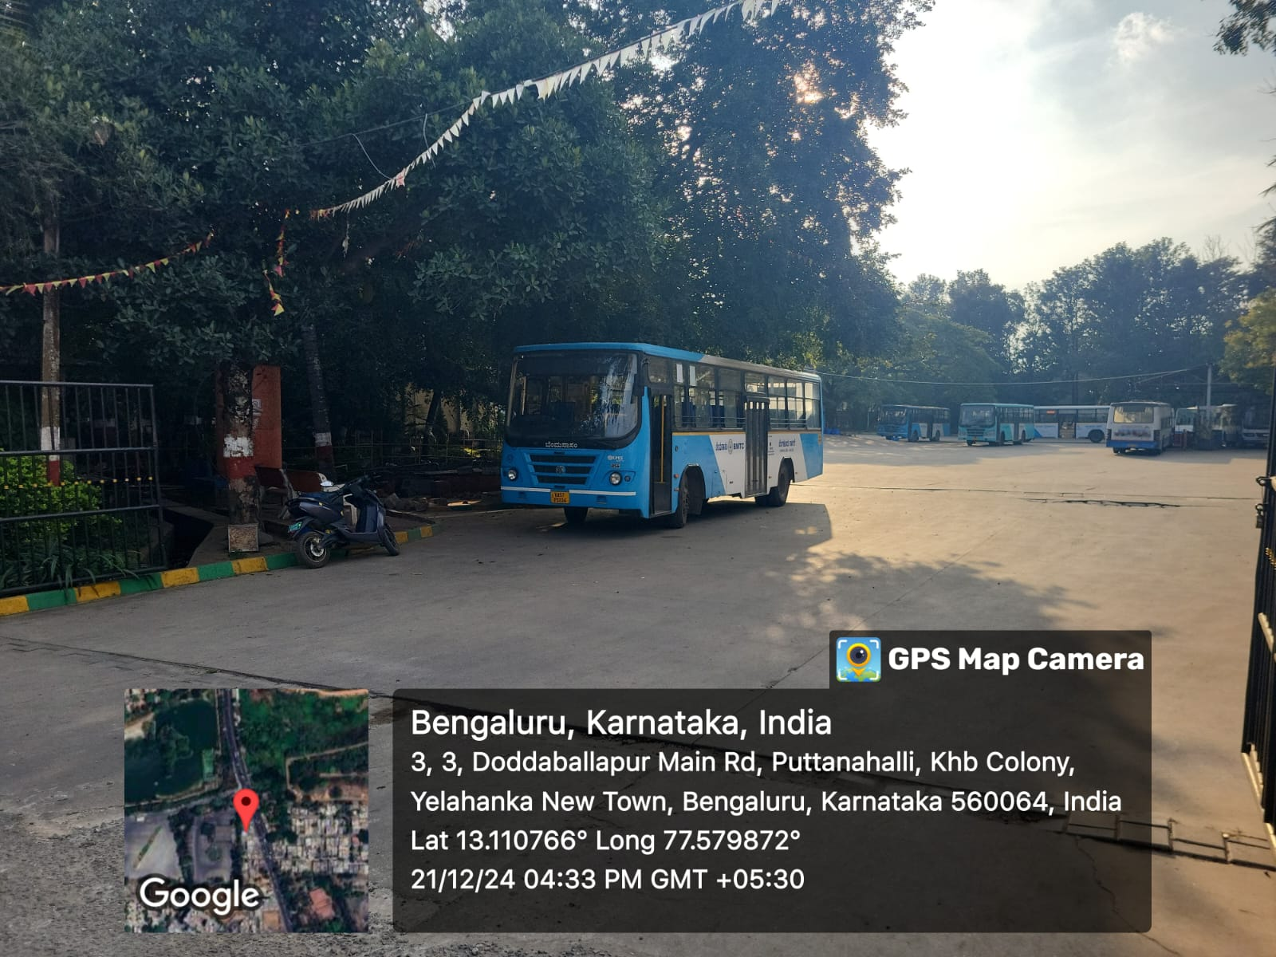

# ACTIVITY – 5

# Food Walk

**1. City’s Culinary Practices**

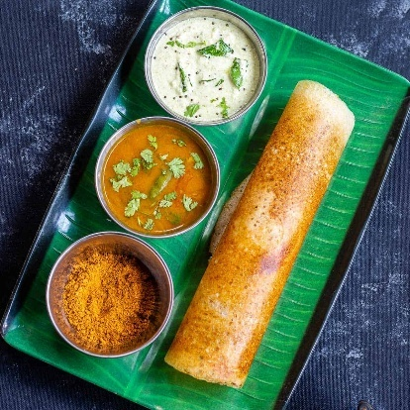The culinary traditions of cities in Karnataka, especially Bangalore, are a vibrant blend of indigenous South Indian cuisine and influences from other regions due to the cosmopolitan nature of the city. Karnataka's culinary practices are diverse and reflect the state's rich cultural and agricultural heritage.

Key Elements of Karnataka’s Culinary Practices:

* Rice as Staple Food: Rice, particularly varieties like Sona Masuri, Mysore Mallige, and Coorgi Rice, is a staple in Karnataka. It is used in a variety of forms: from steamed rice to puliyogare (tamarind rice), bisibele bath (spicy rice and lentil dish), and dosa.
* 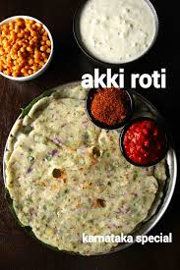Vegetarian Cuisine: Karnataka is known for its predominantly vegetarian cuisine, which is influenced by temple traditions and the state's agrarian culture. Common dishes include Ragi Mudde (finger millet balls), Akki Rotti (rice roti), Saaru (spicy rasam), and Sagu (vegetable curry).
* Use of Spices and Coconut: Spices like mustard seeds, cumin, coriander, curry leaves, and asafoetida are commonly used. Coconut is widely used in various forms (grated, milk, oil), adding flavour and richness to dishes. This is seen in dishes like Mangalore Buns, Neer Dosa, and Coconut Rice.



* Influence of Coastal and Hill Stations: Coastal regions like Udupi,

Mangalore have seafood-based dishes like Mangalorean Fish Curry, Kori Rotti, and Prawn Gassi.

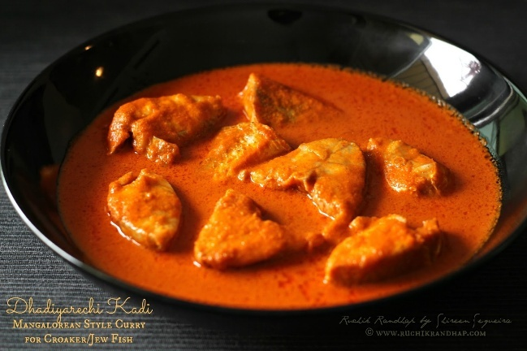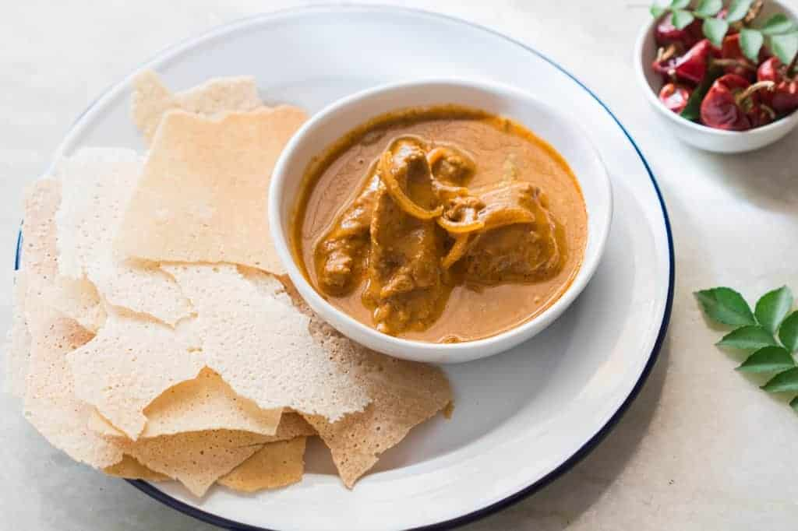

* Diversity in Regional Cuisines:
  + North Karnataka: Known for its spicy, simple fare, including Jolada Rotti (sorghum roti) served with Enne Mamsa (spicy mutton curry).
  + Coastal Karnataka: Features rice-based and seafood dishes, with heavy use of coconut and tamarind.
  + Mysore: Known for its iconic Mysore Pak, Mysore Rawa Dosa, and Mysore Bisi Bele Bath.
  + Malnad (Western Ghats): Known for Akki Rotti, Koli Saaru (chicken curry), and Kadabu (rice dumplings).

**ABOUT FOOD LORE**

Behind every iconic dish lies a fascinating story:

* Bisi Bele Bath: This spicy and tangy rice-lentil dish is believed to have been invented in the royal kitchens of Mysore. It reflects the fusion of South Indian and royal culinary techniques, offering a symphony of flavors with tamarind, coconut, and aromatic spices.
* Mysore Pak: Legend has it that the famous Mysore Pak was accidentally created by royal chef Kakasura Madappa while experimenting with gram flour, ghee, and sugar. The resulting sweet, with its rich texture and buttery flavor, became an instant favorite. Mysore Pak has since evolved, with modern variations including softer versions made with milk and additional ghee, but the original recipe remains a cherished treasure of Karnataka’s royal heritage.
* Udupi Cuisine: Originating in the temple town of Udupi, this cuisine is a shining example of resourceful cooking. Without onion or garlic, dishes like Saaru, Rasayana, and Sambar exemplify the creativity and devotion of temple chefs. The Satvik principles of Udupi cuisine resonate with the spiritual ethos of the region, making it beloved across India.

**GEO Tagged photos of Activity**

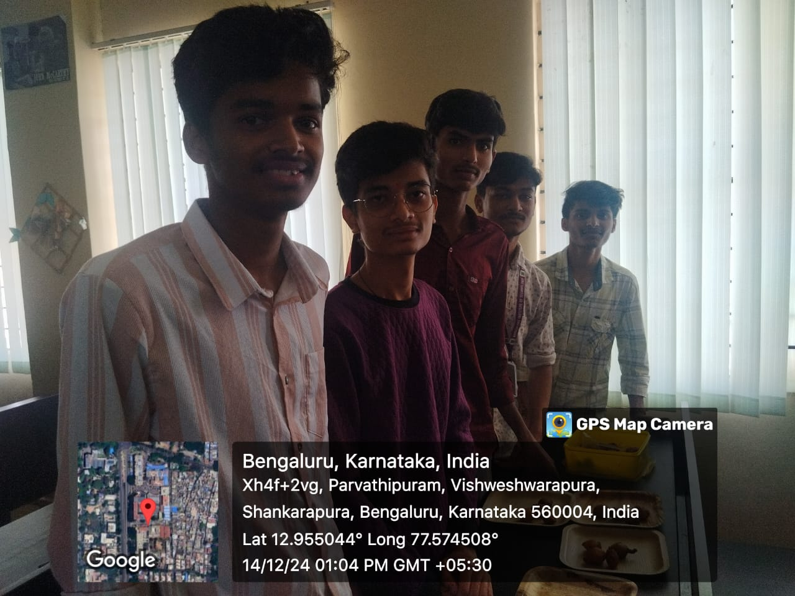

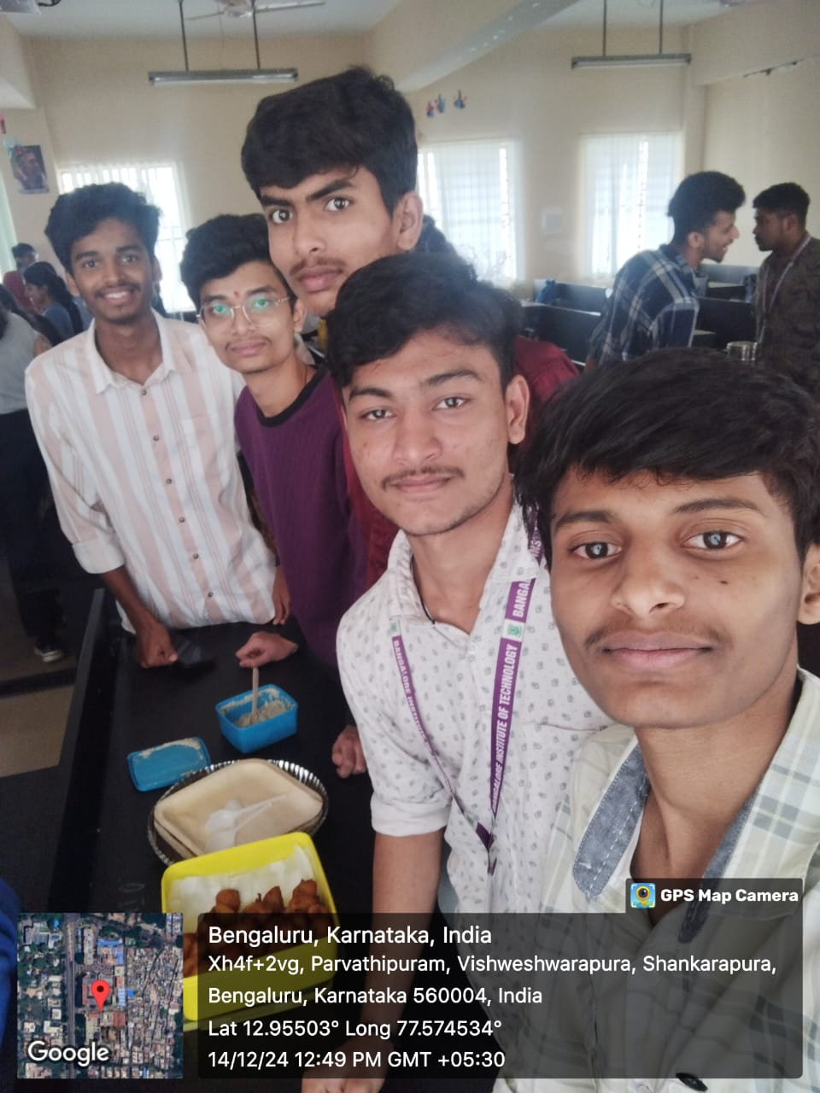

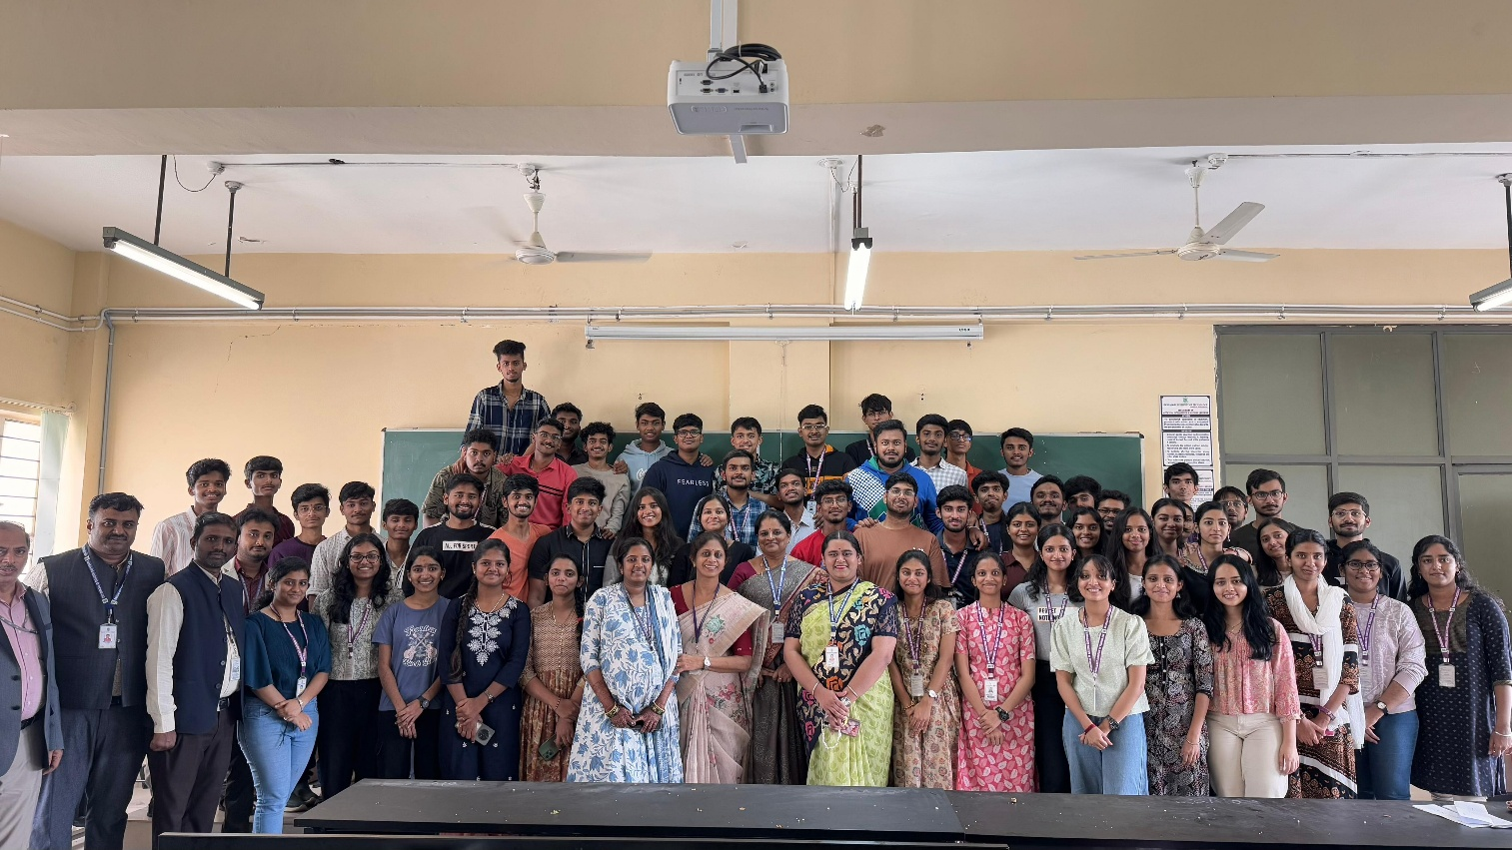

# CONCLUSION

Planting the Indian beech tree (Pongamia pinnata is a significant step toward fostering environmental sustainability. This tree is not only valued for its medicinal properties and adaptability to diverse conditions but also for its ability to improve soil fertility through nitrogen fixation. By planting this tree, I have contributed to enhancing biodiversity, mitigating climate change, and promoting a greener, healthier environment. This initiative reinforces the importance of individual efforts in addressing global environmental challenges, emphasizing that small steps like planting a tree can lead to impactful results over time.

Visiting the historical site in Lepakshi and Isha Foundation was a profound experience that offered a glimpse into the rich cultural and architectural heritage of the region. The site stands as a testament to the craftsmanship and vision of its creators, reflecting the historical, spiritual, and artistic values of the time. Exploring such places not only deepens our understanding of history but also fosters a sense of pride and responsibility to preserve these treasures for future generations.

This visit has been both educational and inspiring, reminding us of the enduring legacy of our ancestors. From completing this activity, we can conclude that Organic Farming is far better than conventional farming because it replenishes natural ecosystems and maintain the balance by keeping water and air cleaner, all without toxic pesticide residues. As for the waste management, our first goal must be to educate the people about the importance of keeping the environment clean must be their main goal only then we can slow and steadily bring the changes we desire. Waste management in India for cities and villages are quite different, so they must be solved using different approach. As a student our responsibility is to create awareness of the clean environment so that people will value the Nature and lead a healthy lifestyle. To sum it up, Water is the foundation of life on the globe. Despite having a lot of water on earth, we are unable to use all of it without making it suitable. So, whatever amount of water reachable is required to be use carefully so that we will not have to face a situation of water scarcity. Water conservation is the key to prevent us from water scarcity. There are lot of ways that we can conserve water at our home, industries and agricultural fields. Instead of waiting for somebody else to start conserving, let us, an individual, take the first step towards conserving water.

The food walk was a flavorful and enlightening journey through Karnataka’s rich culinary heritage. It provided participants with a deep understanding of the historical, cultural, and geographical influences that have shaped the state’s diverse cuisine. The hands-on experiences, from exploring vibrant markets to tasting authentic dishes at local eateries, allowed for a deeper appreciation of the region's gastronomic traditions. Through this activity, participants not only discovered the intricate art of preparing iconic dishes like Bisi Bele Bath, Benne Dosa, and Mysore Pak but also gained insights into sustainable cooking practices and the importance of farm-to-table principles. The stories shared by local chefs and vendors highlighted the deep cultural significance of Karnataka’s cuisine, emphasizing the role of food as a unifying force in communities.

## References

* <https://www.wikipedia.org/>
* <https://www.google.com/maps/place/Lepakshi+Main+temple/>
* <https://www.google.com/maps/place/Isha+Foundation+Chikkaballapura/>
* <https://www.google.com/maps/place/GKVK/>
* <https://www.uasbangalore.edu.in/en/farmers-training-institute/>